Name ___________________________________________ Date _____________
Review for 3rd Quarter Quarterly Algebra II

1. What is the inverse of $y=e^{x}$

2. What is the inverse of $y=\log_{2}{x}$

3. When $f\left(x\right)=\frac{1}{x-1}$ and $g\left(x\right)=\log\left(x\right)+2$ are graphed on the same set of axes, what is one point of
intersection to the nearest tenth?

4. An angle that measures radians is drawn in standard position. In which quadrant does the terminal side
of the angle lie? Find the reference angle and one coterminal angle, in radians.

5. John invests $5,000 at an annual rate of 12% compounded continuously, according to the formula A = Pe^{rt},
where A is the amount accrued, P is the principle, r is the rate of interest and t is the time in years.
Determine how long to the nearest tenth of a year, it will take for the initial investment to double.

6. If the terminal side of angle θ passes through the point (-6,10), what is the value of cscθ?

7. If cos θ < 0 and csc θ > 0, in which quadrant does the terminal side of angle θ lie?

8. A given substance has a half-life of 60 years. The weight of the given substance is 100 g.
Determine how long, to the nearest tenth of a year, for the remaining substance to weigh 20g.

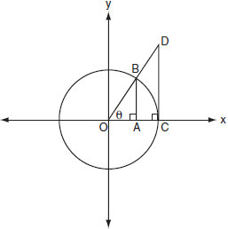
9. In the figure shown, which line segment represents:

$$sinθ$$

$$cosθ$$

$$tanθ$$

9. Using the identity , find the value of $cscθ,$to the nearest hundredth, if is –0.3 and is
in Quadrant III.

10. State the domain, range and asymptote for $y=\log{x}$

11. Algebraically solve the following system of equations:

x + 2y – 3z = -3
2x – 5y + 4z = 13
5x + 4y – z = 5

12. Your grandparents gave you $2000 to invest for your college when you are born. You have two investment
options. One will pay 2.7% interest compounded monthly, $A=P{\left(1+\frac{r}{n}\right)}^{nt}$. The second will pay 2.3%
compounded continuously ($A=Pe^{rt}$).
  - Write a function for each option that calculates the value of each account after t years.
  - Determine which plan will have more money saved in 18 years.
  - Algebraically determine, to the nearest tenth of a year, how long it would take for the second plan to reach $7000.

