Homework
Use the accompanying diagram f(x) to answer questions 18 – 24
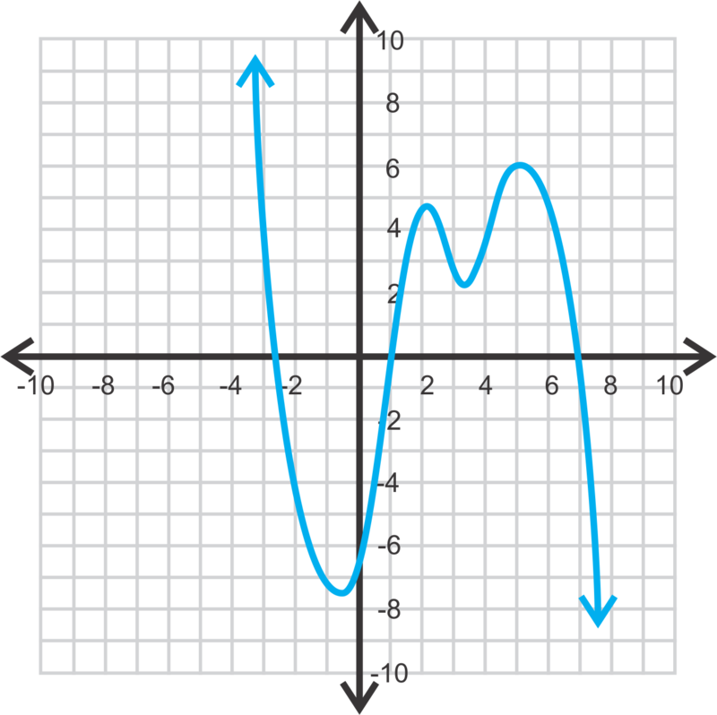

1) Find all solutions that satisfy f(x) = 0

2) Give the points that satisfy the relative minimum

3) Give the points that satisfy the relative maximum

4) For what interval is f(x) always increasing?

5) For what interval is f(x) always decreasing

6) f(x) has an absolute maximum value of ______________

7) f(x) has an absolute minimum of ___________________

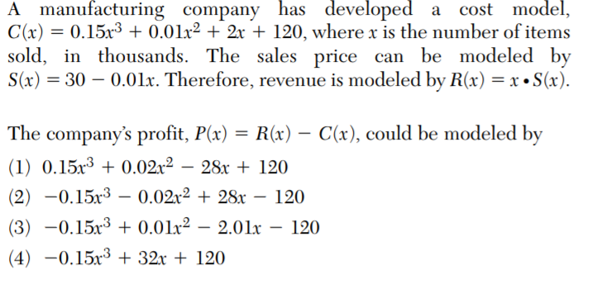
8)

